**Building a Simple User Interface:**

1. In Android Studio, from the res/layout directory, open the activity_my.xml file.

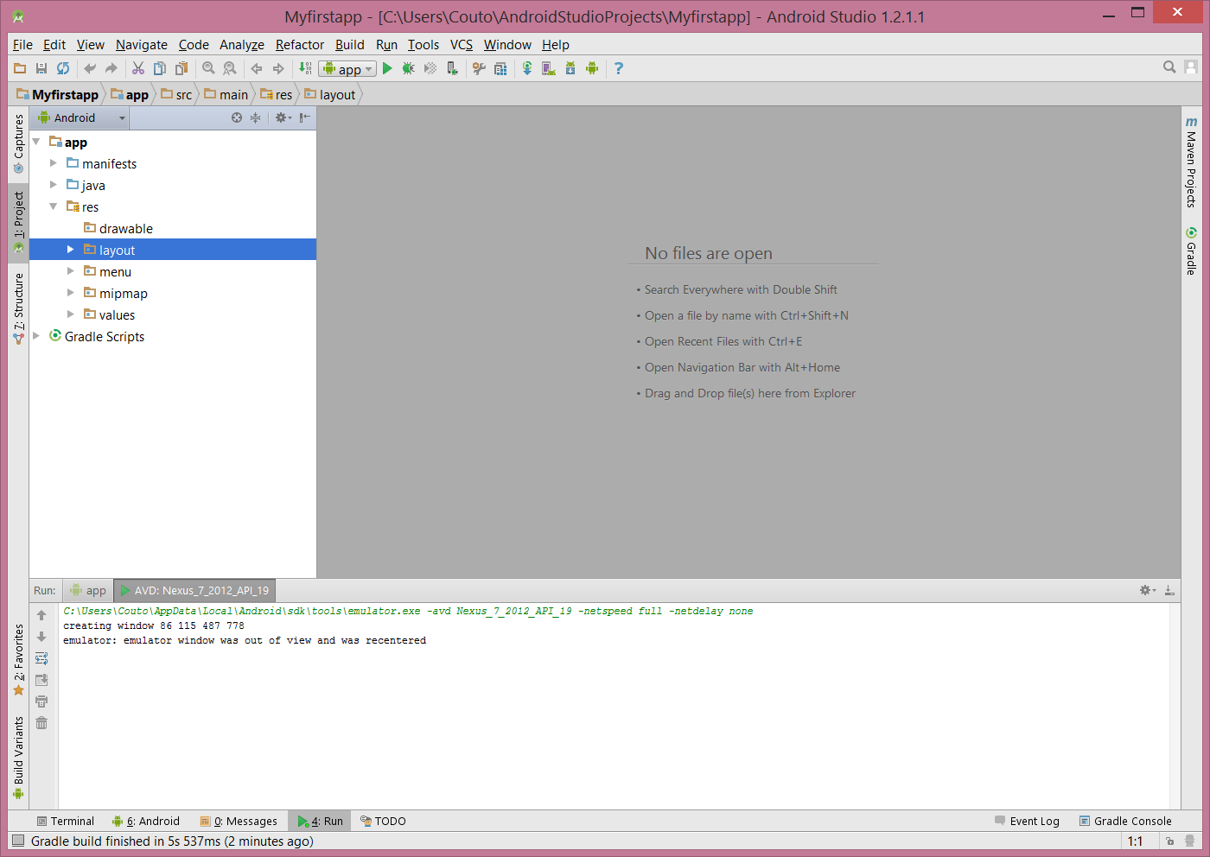

1. Hide preview and open the “Text” tab.

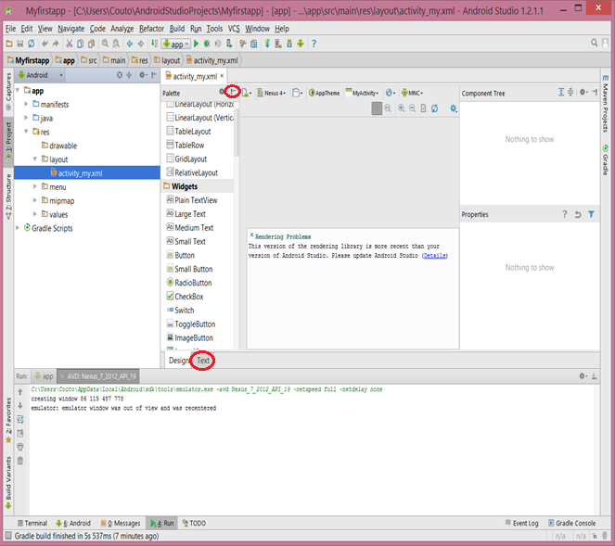

1. Create a Linear Layout

* Delete the <TextView> element.
* Change the <RelativeLayout> element to <LinearLayout>.
* Add the android:orientation attribute and set it to "horizontal".
* Remove the android:padding attributes and the tools:context attribute.

Result:

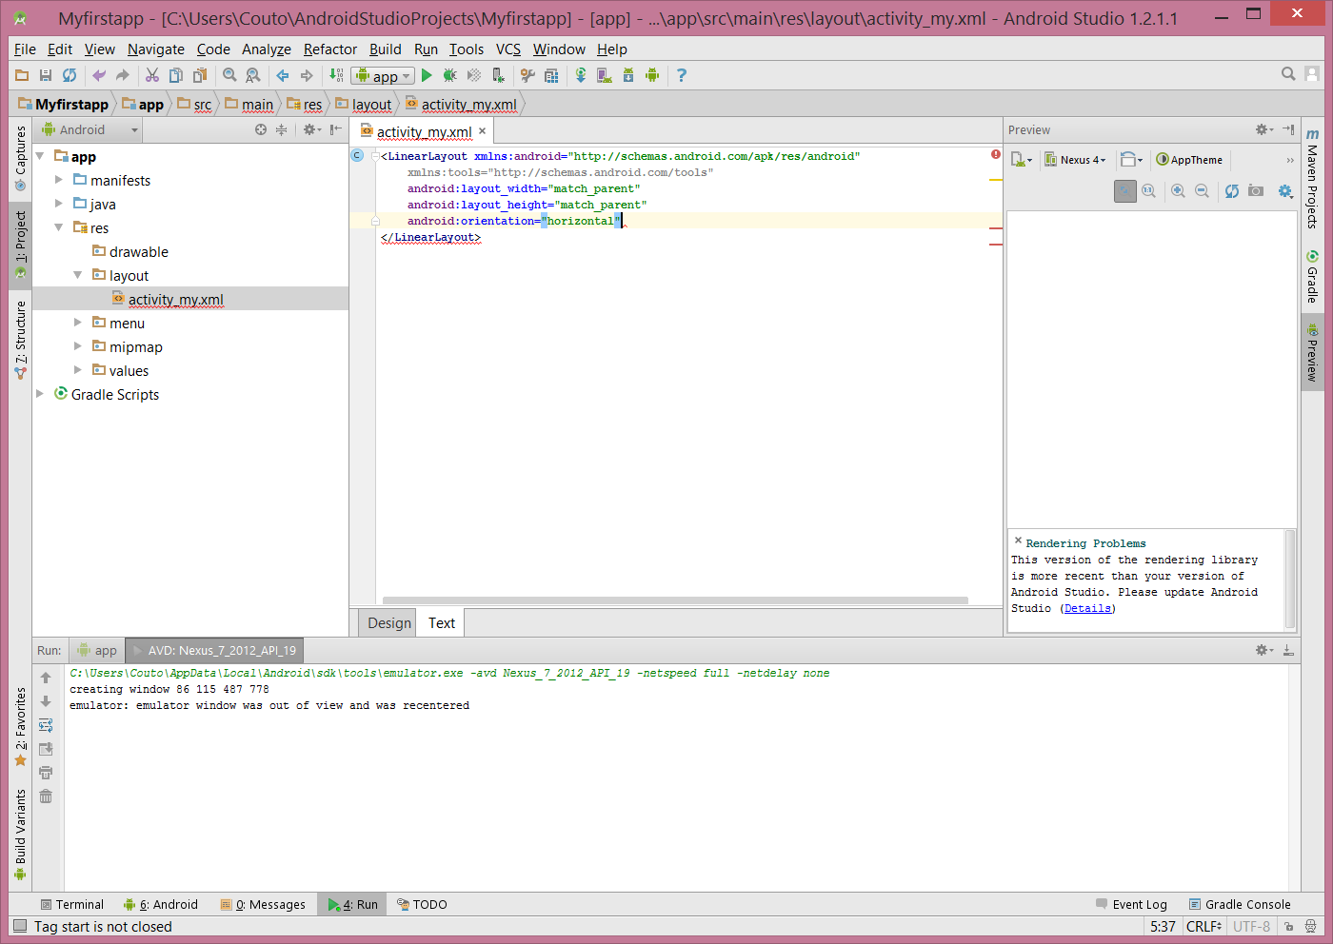

1. Add a text field.

* In the activity_my.xml file, within the <LinearLayout> element, define an <EditText> element with the id attribute set to @+id/edit_message.
* Define the layout_width and layout_height attributes as wrap_content.
* Define a hint attribute as a string object named edit_message.

Result:

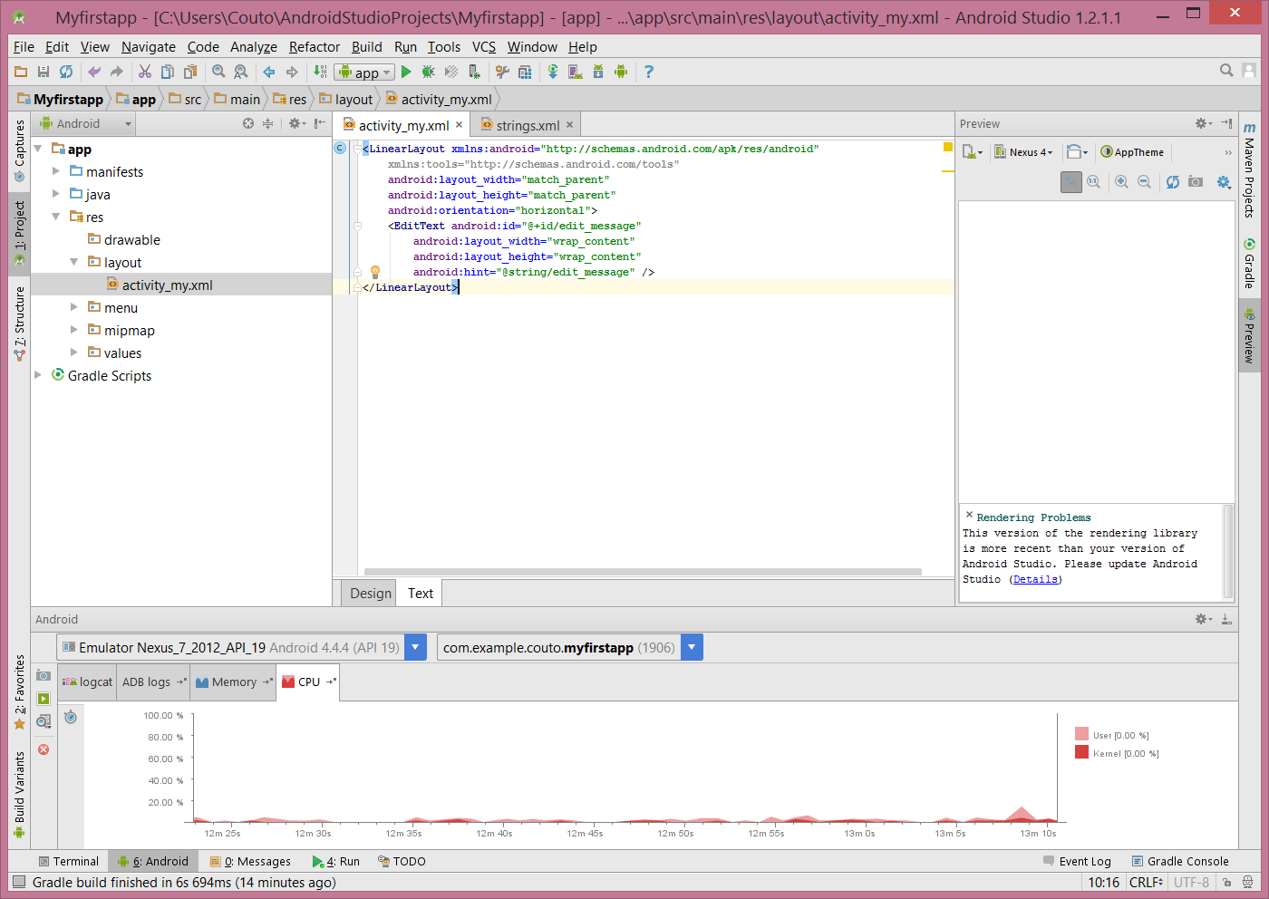

1. Adding string resources

* In Android Studio, from the res/values directory, open strings.xml.
* Add a line for a string named "edit_message" with the value, "Enter a message".
* Add a line for a string named "button_send" with the value, "Send".
* You'll create the button that uses this string in the next section.
* Remove the line for the "hello world" string.

Result:

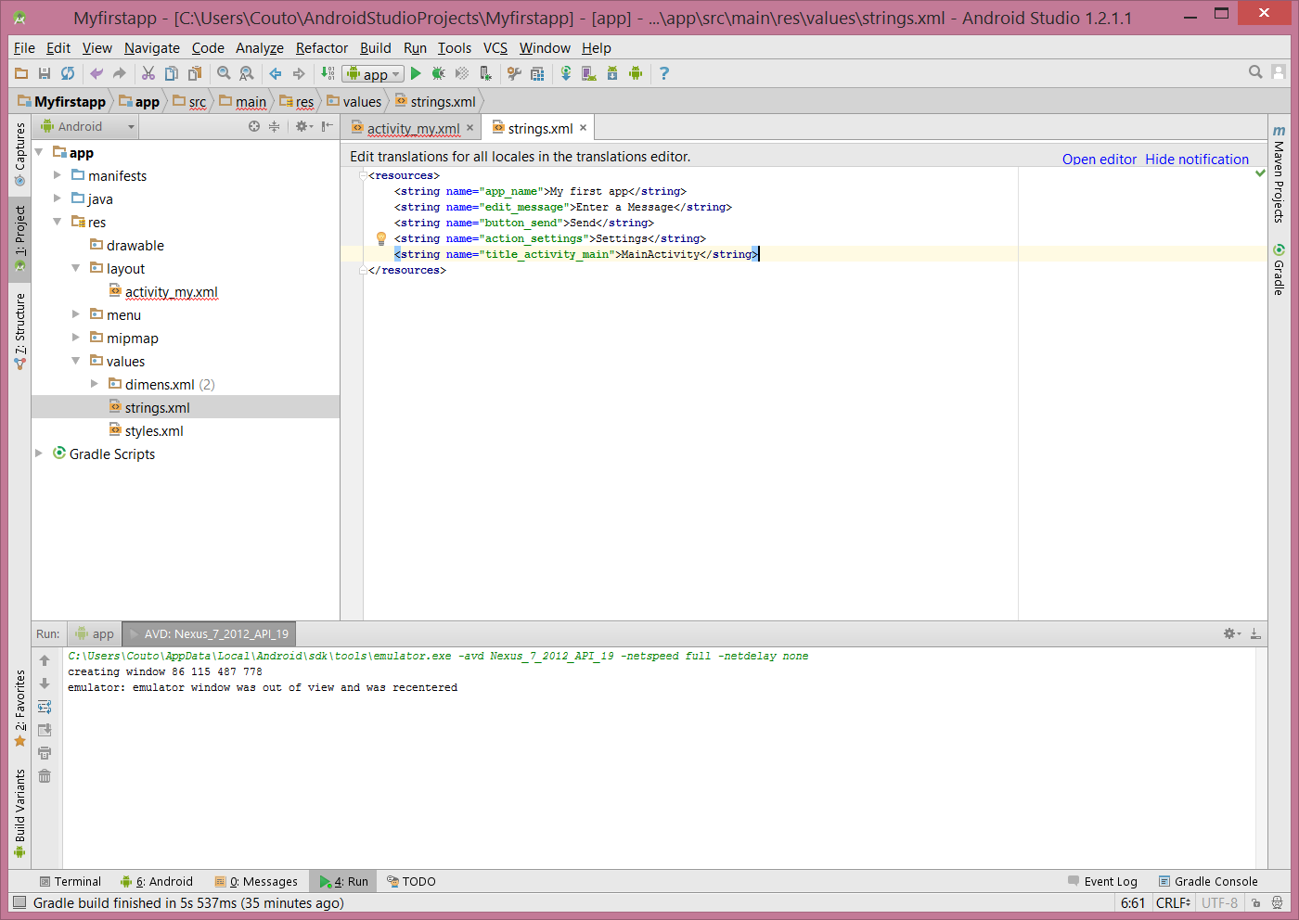

1. Adding a button.

* In Android Studio, from the res/layout directory, edit the activity_my.xml file.
* Within the <LinearLayout> element, define a <Button> element immediately following the <EditText> element.
* Set the button's width and height attributes to "wrap_content" so the button is only as big as necessary to fit the button's text label.
* Define the button's text label with the android:text attribute; set its value to the button_send string resource you defined in the previous section.

Result:

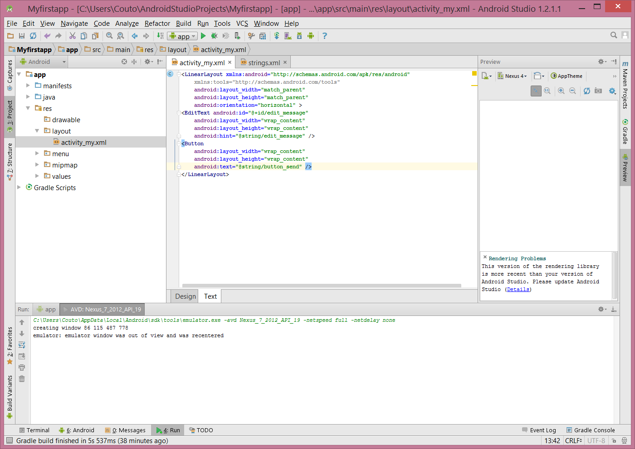

1. Make the input box fill in the screen width

* In the activity_my.xml file, assign the <EditText> element's layout_weight attribute a value of 1.
* Also, assign <EditText> element's layout_width attribute a value of 0dp.

Result(Final):

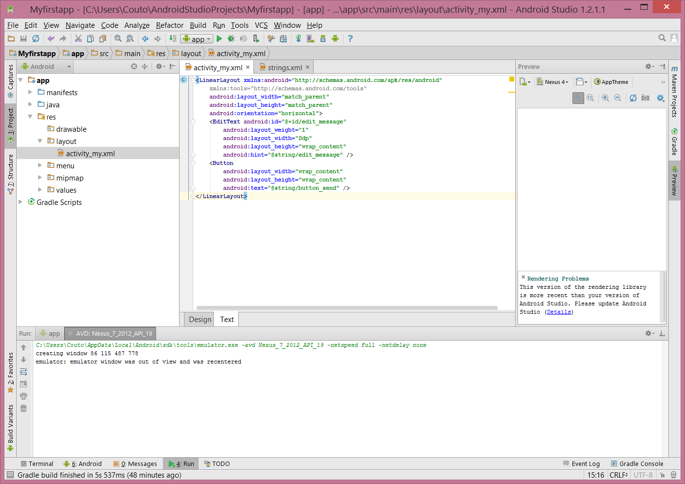

1. Run your app!

Result:

